Wider Curriculum Home Learning – What is our world like? Is it all the same? What can we do to look after it?
This week is all about Our World! Select from the activities below
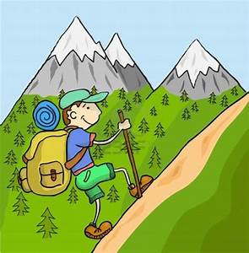  Mountains  Some parts of our world are much higher and have tall mountain ranges.  Visit this Bitesize page for an introduction to Mountains and what it is like to live in the German Alps  https://www.bbc.co.uk/bitesize/articles/zbqsvk7  - You could research one of the world’s mountain ranges or a particular mountain and create a fact file  - You could research how mountains are formed and learn about tectonic plates.  - Make your own mountains  https://safeYouTube.net/w/i5tM | 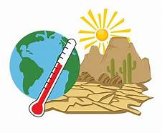  Weather and Climate  Although we might moan about the weather in this country as it seems to be hot one day and raining the next – we actually have it pretty good. Visit this Bitesize page to find out about weather and climate across the globe https://www.bbc.co.uk/bitesize/articles/z4xdqp3  - You could choose another country and investigate the climate there. Maybe Nigeria / New Zealand or Siberia- write a weather report  - Learn about what the Earth can tell us about the weather with Sir David Attenborough  https://www.bbc.co.uk/bitesize/articles/zw7vtrd | 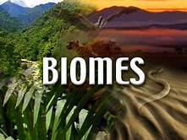  Biomes  https://safeYouTube.net/w/N3tM  Biomes are areas of our planet with similar climates, landscapes, animals and plants. What lives in each biome depends on:  how warm or cold it is, how dry or wet it is, how fertile the soil is  Visit this BBC Bitesize page to find out about different biomes.  https://www.bbc.co.uk/bitesize/topics/z849q6f/articles/zvsp92p  - Investigate one of the different biomes and find where they are on a map and research how they are different to where we live.
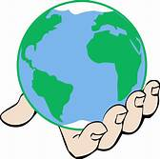  Your World  Focusing on geographic themes such as size, climate and terrain, this series compares the experiences of children living in the UK to contrasting places around the world.  https://www.bbc.co.uk/teach/ks2-geography/zj7p47h  David Attenborough  Learn what the Earth can tell us about the weather with Sir David Attenborough. Go to this site and https://www.bbc.co.uk/bitesize/articles/zw7vtrd | 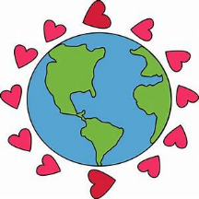  Blue Planet live lesson  Watch the Blue Planet Live lesson here  https://www.bbc.co.uk/teach/live-lessons/blue-planet-live-lesson/zn7tkmn  As the lesson plays there are activity sheets – these are in the folder  - Use some of your plastic from your recycling -Design and or make a plastic sculpture.  - Promote the use of other materials – design a poster | 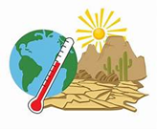  Climate Change  Climate change is in the news quite a lot – but what is it?  https://safeYouTube.net/w/n3tM  What could you do to slow it down?  - Investigate climate change and how you could help slow it down- design a poster for your window  - Watch the Powerpoint for more information  - Have a go at filling in the sheet about what you could do
Remember to share your work with your teacher using seesaw or the class email address

