Wider Curriculum Home Learning – Computing
Programming using Scratch
You will need Scratch 2 or 3 - or create an account at https://scratch.mit.edu/ to complete the activities online
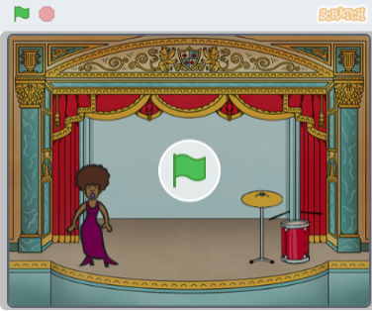  Learn to code your own musical instruments.  By completing this activity you will learn how to interact with sprites, change a sprite's costume, make use of user input and include sounds in your Scratch program. Use the link below:  https://projects.raspberrypi.org/en/projects/rock-band | 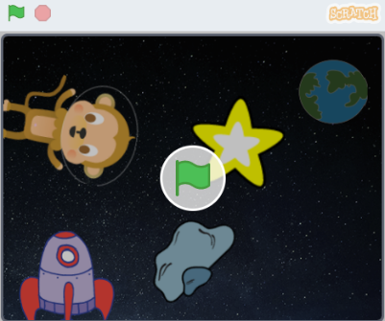  Learn how to repeat...  By completing this activity you will use Scratch to learn how to program your own animation including how to repeat instructions. Use the link below:  https://projects.raspberrypi.org/en/projects/lost-in-space | 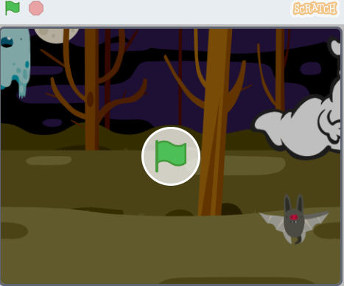  Learn how to use variables...  By completing this activity you will learn how to make a ghost-catching game including the use of variables. Use the link below:  https://projects.raspberrypi.org/en/projects/ghostbusters
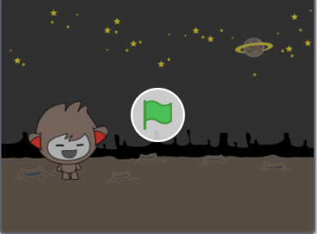  Learn how to use selection...  By completing this activity you will learn how to make a chatbot, you'll program a character that can talk to you. Use the link below:  https://projects.raspberrypi.org/en/projects/chatbot | 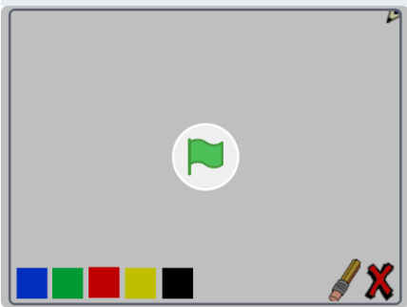  Learn how to use Boolean operators...  By completing this activity you will learn how Boolean operators work while creating your own paint program. Use the link below:  https://projects.raspberrypi.org/en/projects/paint-box | 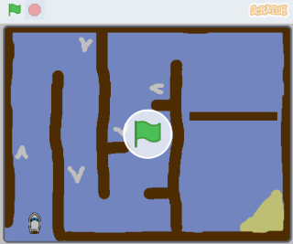  Learn how to create your own working game...  By completing this activity you will learn how to develop your own boat racing game.  Use the link below:  https://projects.raspberrypi.org/en/projects/boat-race
Remember to share your work with your teacher using seesaw or the class email address

