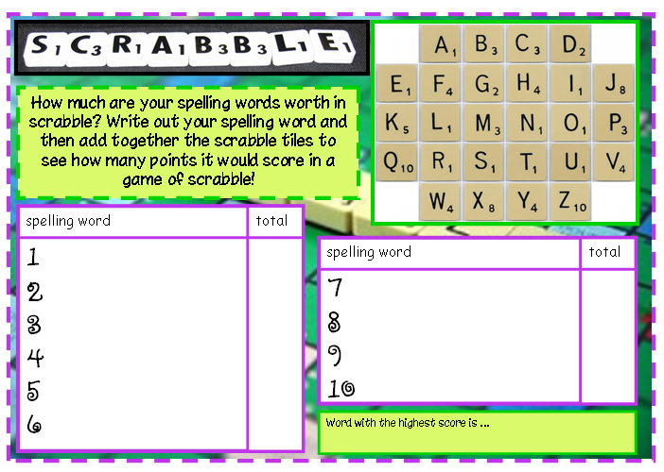
Spellings Task – Wk 3 - w.b. 30th March
The following list of words are from the Year 5 and 6 spelling list. Please help your child to learn to spell these words and use them in context.

Monday | Tuesday | Wednesday | Thursday | Friday
identity | immediately | mischievous | occur | prejudice
immediate | language | muscle | opportunity | privilege
individual | leisure | necessary | parliament | profession
interfere | lightning | nuisance | persuade | programme
interrupt | marvellous | occupy | physical | pronunciation
Task
- Practise each word.
- Write each word in a sentence in context.
- Chose a task from the list below.

Year 6 Spellings Menu
Choose a task to complete each week. Complete / record this task in your book.
1 | Look up the meaning of your words in the dictionary, noting down in your books any you did not know before. Do they have a root word? (e.g. create- creation)
2 | Put your spelling words into alphabetical order.
3 | Speed writing! How many times can you write out a chosen spelling in one minute? You only get a point if the word is spelt correctly and you can read it!
4 | Copy out your spellings. Use another colour pen / pencil to circle the consonants.
5 | Write out your spellings in your spelling books, using a different colour for vowels and consonants
6 | Take a paintbrush and a pot of water outside and write out your spellings on the ground. Can you write out all of your spellings before they disappear?
7 | Write out your spellings in a pyramid. Start with the first letter. Underneath write the first two letters, underneath write the first three letters and so on until you complete the word. When you are finished your word will be in the shape of a pyramid.
8 | Write your spellings out in different styles of writing e.g. bubble, italic to help you learn them.
9 | Learn your spellings by writing each word out several times using your best joined handwriting.

