Writing Tasks – Wk 3 – w.b. 30th March
Day 1
Design your own theme park! You could draw your theme park, make it on computer software e.g Minecraft, Rollercoaster Tycoon (if you have it), use Lego to create your own theme park. Be creative!
Day 2
 | Generate vocabulary based on the picture.  Thoughts, feelings, colours. Use your five senses. Think about figurative language:  Similies, Metaphors, Personification, Alliteration,  hyperbole (exaggeration)  You could plan your ideas using the planner shown as a scaffold.

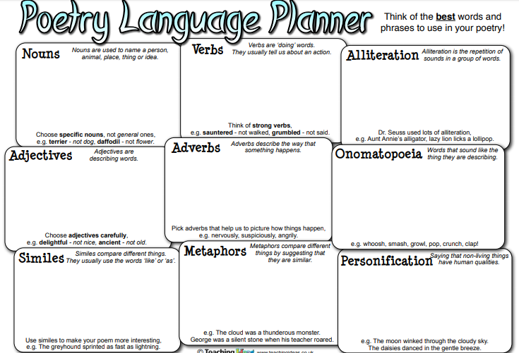

Day 3
Create a poem based on the ideas you planned. You could create a shape poem, examples are below.
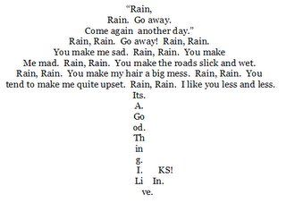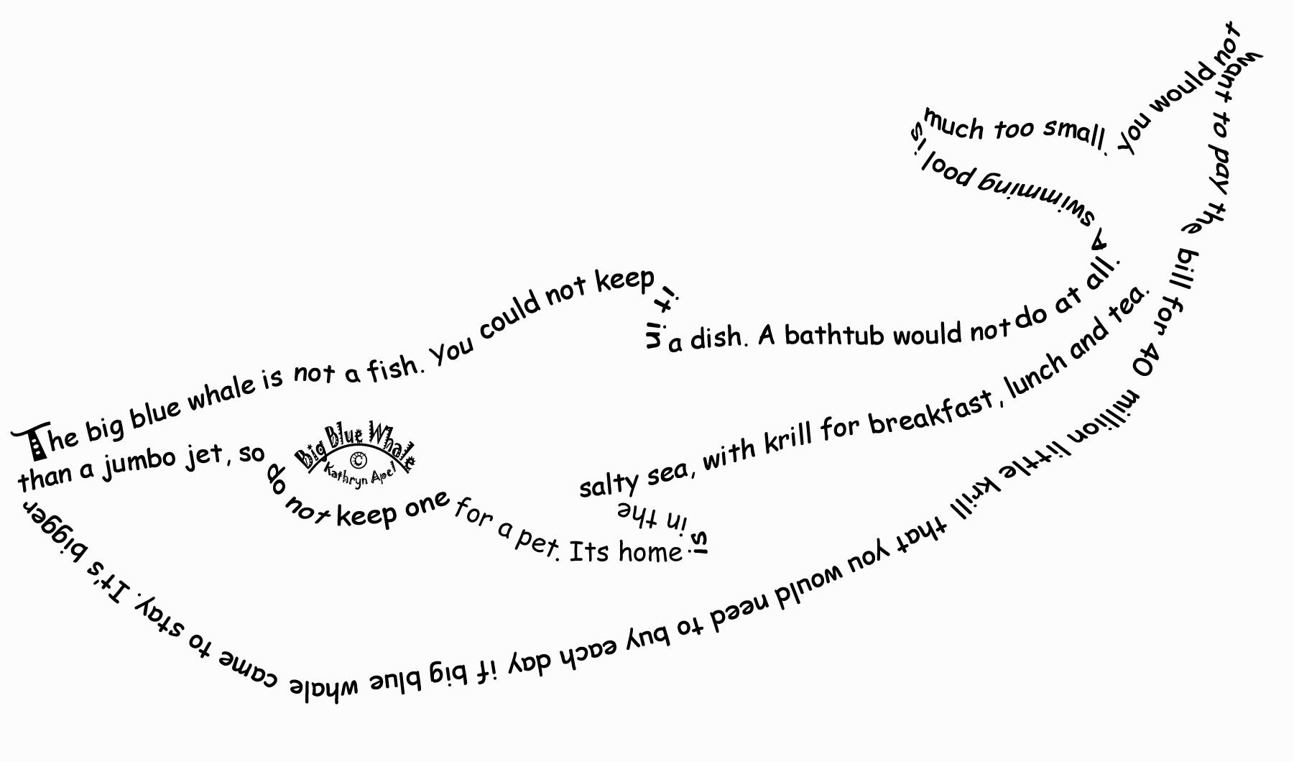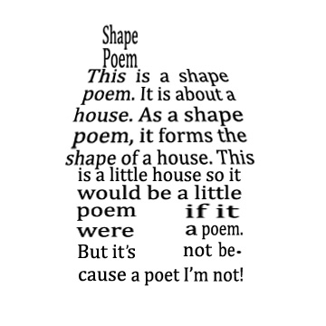

Day 4
Create a setting or character description based on your theme park. Remember to use some of your ideas you’ve thought of so far.
Day 5
Create a review of your theme park.


