Monday

- 245 x 6 =

- 73 x 42 =

- 732 ÷ 4 =

- 2880 ÷ 12 =

- 37395 + 9876 =

- 398964 + 5789 =

- 4835 - 287 =

- 432031 – 8796 =

- 843.86 + 495.3 =

- 743.02 – 49.5 =

Tuesday

- Write 12,503,074 in words.

- Write eighteen million, seven hundred and forty thousand, two hundred and five in numerals.

- What is the value of the underlined digits?
3,402,942
8,489,931
9,412,841

- Round 849,381 to the nearest:
10 =
100 =
1000 =
10,000 =
100,000 =

- Round 638.52 to the nearest:
Tenth =
Whole =
10 =
100 =

Wednesday

- $\frac{8}{12}$ + $\frac{3}{12}$ =

- $\frac{12}{16}$ - $\frac{7}{16}$ =

- $\frac{3}{8}$ + $\frac{6}{16}$ =

- $\frac{3}{4}$ + $\frac{4}{12}$ =

- $\frac{9}{12}$ - $\frac{1}{3}$ =

- $2\frac{1}{3}$ + $\frac{5}{6}$ =

- $4\frac{2}{6}$ - $\frac{5}{6}$ =

- $\frac{3}{8}$ x $\frac{4}{5}$ =

- $\frac{5}{6}$ x $\frac{3}{9}$ =

- $\frac{4}{6}$ ÷ 3 =

Thursday
- Match:
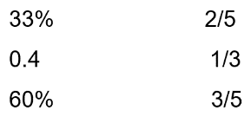

- Order these in ascending order:
$\frac{35}{10}$ 35% 3.6 $\frac{36}{100}$

- Order these in descending order:
2.75 $\frac{48}{10}$ 27% $4\frac{1}{2}$

- Insert the correct symbol (< > =)
54% 0.54

$\frac{3}{6}$ 52%

$\frac{3}{5}$ 0.4

- 15% of 400 =

- 98% x 800 =

- 55% x 650 =

- $\frac{1}{5}$ of 40 =

- $\frac{4}{6}$ x 48 =

- $\frac{7}{9}$ x 252 =

Friday

- 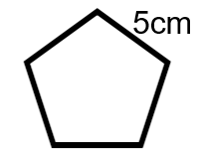What is the perimeter of this regular pentagon?

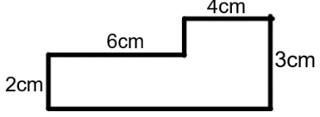

What is the area?
What is the perimeter?

- The area of a shape is
36 cm². What could its dimensions be?

- What is the perimeter?
What is the area?
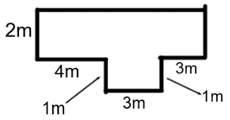

- Each side of a regular hexagon is 12 cm. What is its perimeter?

- What is the volume of this cuboid?
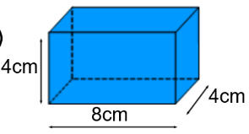

- The perimeter of a regular octagon is 48cm. What is the length of one side?

- a

If angle a is 55°, what is angle b?

- What is the area of this triangle?

- What is the volume of a cube with a height of 6cm?

