Writing Tasks – week 4 – w.b. 20th April
All of your tasks this week are based on this picture and the opening of a story below:
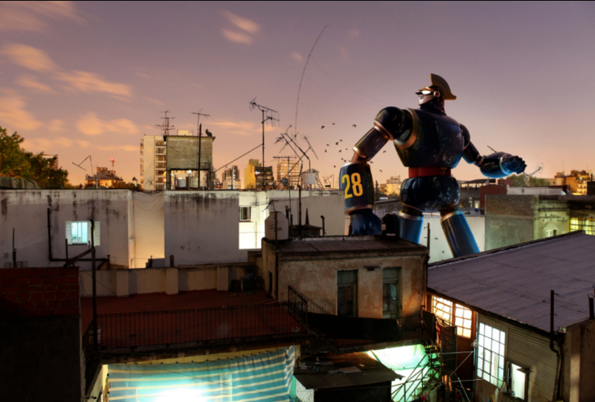\
Thump…Thump…Thump…His footsteps thundered down the road, causing passers-by to stare in amazement, dogs to howl in back yards and alarmed old ladies to peer out of their bedroom windows wearing petrified looks on their faces.
His legs were as long as oak trees, his torso was as wide as a house and his fists were as heavy as tractors: this metallic monster meant business.
“Number 28 checking in. Over.” He spoke into the radio set, built in to his helmet.
His instructions crackled back through the earpiece. He knew what he had to do…
Day 1
Think about the questions below and write or discuss your answers with a member of your family.
- Who/what is Number 28? What is his mission? Where has he come from? Who is he speaking to?
- Do robots have feelings? Will there be robots around in the future?
- If we all had a personal robot that belonged to us, would this be a good thing or a bad thing?
- Does a robot need to eat food, or do they need fuel?
- What is the difference between fuel and food?

Day 2 - planning
We would like you to continue the story from the story opener. But first, we need to plan our writing! You could do this by doing a ‘S’ plan in your books and thinking about it step by step.
Remember to:
- Add feelings/emotions of any characters you put it
- Describe the setting
- Use powerful verbs, use an online thesaurus to help you improve your vocabulary!
- Use powerful adjectives – use an online thesaurus to improve your vocabulary!
- Begin to think about your sentence openers – ADDSPICE (adverbs, drop-in clause. Description, simile, personification, -ing word, conjunctions, -ed word)
- Use varied sentence structures and lengths. Remember short sentences help to build suspense!

Day 3 – develop your sentences
- Up level this sentence: He was really big. People were scared. His big body walked down the street.
- Can you write a sentence that uses an apostrophe for omission? ! E.g. cannot =can’t ! I have = I’ve ! he will= he’ll
- Can you write a sentence that uses an apostrophe for possession? ! E..g. The robot’s suit ! Number 28’s head
- Write a sentence with parenthesis (extra information about a noun, that uses brackets ( ) commas ,, or dashes - - )
- Write a sentence that begins with a subordination conjunction (A WHITE BUS) at the beginning of your sentence.
- Write a sentence with a subordinate clause the end of you sentence.
- Write sentence that uses a semi-colon. Semi-colons are often used to replace a co-ordinating conjunction.
- Write a sentence using each of the ADDSPICE openers.
By the end of today’s sessions, you should have written 15 sentences that you could use in your story.

Day 4 – Write your story!
Think about the success criteria at the top of the page and the sentences you have already written.

Day 5 – Edit your story.
When we edit, remember to check for:
- Sense
- Punctuation
- Spellings
- Opportunity to improve your vocabulary
- the success criteria (see the top of this page!)
Remember to send out stories to your teachers! We are keen to read your pieces of writing and see how creative you have been

