Harry Potter and the Philosopher’s Stone
Task A: Chapter 2 – The Vanishing Glass

- Why did the Dursleys buy Harry an ice-lolly from the van at the entrance to the zoo?
Tick one.

They wanted him to have a nice time
There were no chocolate ice-creams left

The lady asked Harry before they could get away

Strawberry ice-cream was his favourite

- Circle the correct option to complete each sentence below.

- The gorilla looked remarkably like Dudley except for his…
itchy head
long arms
blond hair
new glasses

- Dudley had a tantrum because…
his mum bought Harry an ice-cream
his knickerbocker glory wasn’t big enough
he couldn’t hit Harry
Harry came along

- The boa constrictor was born in…
the zoo
Hogwarts
Brazil
Canada

- Dudley was disappointed with the boa constrictor because…
it was asleep
it wasn’t really from Brazil
it wouldn’t talk to him
it was too small

- Which word best describes Harry’s feelings towards the snake?

Tick one.
jealousy

empathy

fear

anger

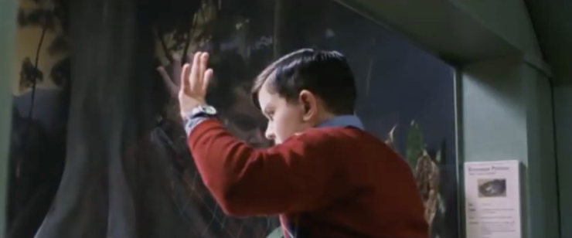
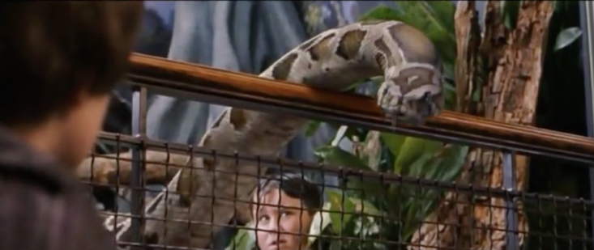
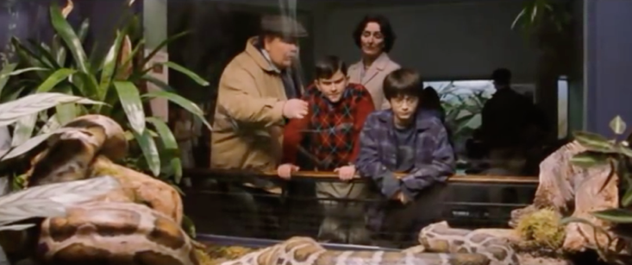
- Which of these images best describes the scene at the reptile house at the end of the text?
Tick one.

- Alliteration is used with good effect to describe the snake moving: the snake slid swiftly. Can you think of any other alliterative phrases that could describe a zoo animal or the way it moves?
_______________________________________________________________________________________________________________________________________________________________________________________________________________________________________________________________________________________________________________________________________________________________________________________________________________________________________________________________________________________________________________________________________________________________________________________

