Harry Potter and the Philosopher’s Stone
Task B: Chapter 2 – The Vanishing Glass

- Which items were sold from the van at the entrance to the zoo?
Tick two.

Sweets
Chocolate ice-creams

Lemon ice lollies

Strawberry ice-cream

- Circle the correct option to complete each sentence below.

- The text begins with Harry and the Dursleys going on a trip to…
an ice-cream shop
Hogwarts
the zoo
the cinema

- Dudley had a tantrum because…
His mum bought Harry an ice-cream
His knickerbocker glory wasn’t big enough
He couldn’t hit Harry
Harry came along

- The boa constrictor was born in…
The zoo
Hogwarts
Brazil
Canada

- Everything was fine for Dudley at the zoo until…
The shop ran out of ice-creams
The glass on the snake’s tank disappeared
Aunt Petunia forgot to buy a present
His friend left

- Which word best describes how Harry was feeling when Dudley punched him in the ribs?

Tick one.
Angry

Scared

Upset

Surprised

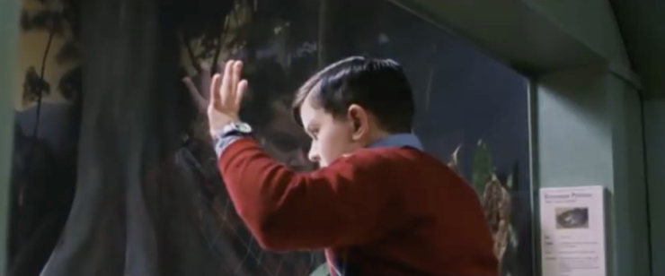
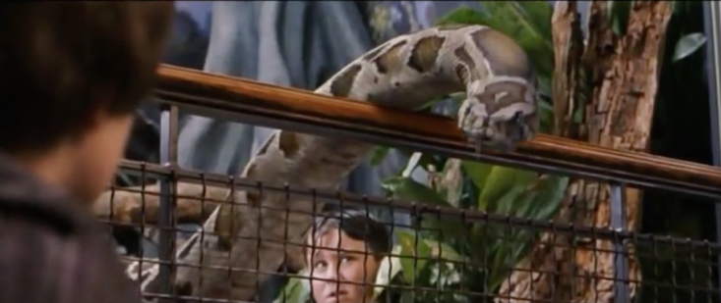
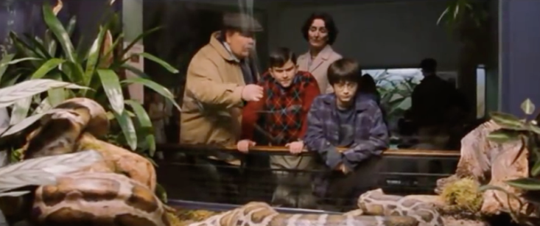
- Which of these images best describes the scene at the reptile house at the end of the text?
Tick one.

- With which zoo animal would you like to have a conversation? Explain why and write some of your first conversation. Remember to punctuate the dialogue correctly.
_______________________________________________________________________________________________________________________________________________________________________________________________________________________________________________________________________________________________________________________________________________________________________________________________________________________________________________________________________________________________________________________________________________________________________________________

