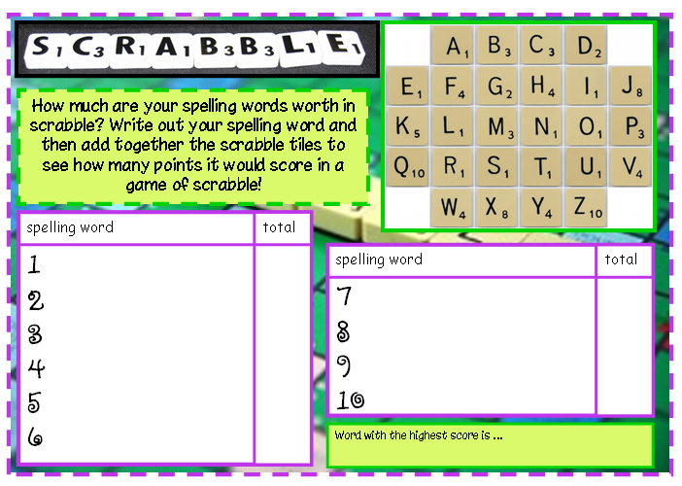
Spellings Task – Wk 4 - w.b. 27th April
The following list of words are the words for you to learn this week. Complete the tasks given below based on these words.

programme | telegram | hologram | parallelogram | monogram
diagram | grammar | grammatical | programmer

Monday | Tuesday | Wednesday | Thursday | Friday
Look up the meaning of your words in the dictionary or online dictionary, noting down in your books any you did not know before. Do they have a root word? (e.g. create- creation) | Speed writing! How many times can you write out a chosen spelling in one minute? You only get a point if the word is spelt correctly and you can read it! | Write each word in a sentence in context. | Write out your spellings in your spelling books, using a different colour for vowels and consonants | Write your spellings out in different styles of writing e.g. bubble, italic to help you learn them.

There is also a word search and crossword if you are able to print and wanted extra practise

