Writing Tasks – week 5 – w.b. 27th April
Your tasks for writing this week are all based around the following picture and sentences:
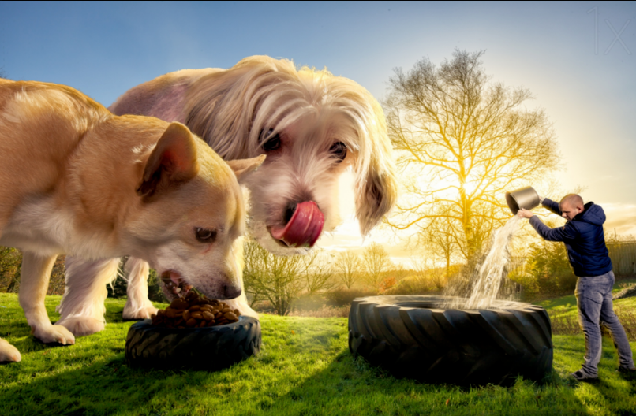
David had often bought things off the internet that soon turned out to be outrageous, disappointing fakes. He had presumed that the bone-shaped biscuits (labelled as 'magic') would be exactly the same. How wrong he had been!
Day 1
Today’s task is to design the bone-shaped biscuits (labelled as 'magic') that David bought. You will be thinking about the biscuits and the packaging of the product. Please have a go at drawing and then annotating your drawing with some key information – below are some key questions that you may want to add to your work!
- What colour are the biscuits?
- What ingredients are included in the biscuits?
- What is the product's name?
- Where can you buy these biscuits from?
- Are they designed for animals or anyone that wants to eat them?
- What is the nutritional information?
- What persuasive line does the packaging use to entice their consumer into buying them?
Day 2
Today we would like you to think and either discuss with a member of your family or make bullet pointed notes to the following questions:
- Why did David give the dogs his biscuits?
- What happened when David fed the biscuits to his dogs?
- How quickly did they grow to this size do you think?
- Did David give the biscuits to anything/anyone else?
- Have the creatures stopped growing?
- How will David keep them as pets?
- What are the benefits/problems with having such enormous pets?
- Is there a way for David to restore his animals to their original size?

Day 3
Today, we would like you to show us and your family what fantastic writers you are! It is time for you to up-level the 4 sentences below. We are expecting high quality work where every word is purposeful and creates an image for your reader. Remember, in year 6 you should be using:
High level punctuation () - ; :
Fronted adverbials (time, place, manner, frequency, degree)
Figurative language (similes, metaphors, personification, alliteration)
Co-ordinating conjunctions (FANBOYS – for, and, nor, but, or, yet, so)
Subordinating conjunctions (AWHITEBUS – although, when, if, that, even though, because, until, since – and others!!)
Parenthesis (extra information marked by () - , )
Direct speech (think about the rules for direct speech and that you need "to open and close the speech")

- David lived at 12 Grassmere Way with his two dogs and wife called Sarah.
- One evening, David decided to log onto his computer. He called down to Sarah and asked if he should order a bulk delivery of the dog food they normally bought from Amazon.
- The dog stood tall and looked almost proud of himself. He had white fur and always wagged his tail.
- Lifting the bucket off of the floor and filling it with water, David realised he would need to do this at least 100 times to fill the tyre that his pets now drank from. Suddenly, he had an idea.

Day 4
Can you create a poem today based on the picture? We would like the poem to rhyme and have 4 stanzas (paragraphs in poems).
You might want to write your poem from the point of view of David, one of the dogs, David’s neighbour, the postman who delivered the biscuits or anyone else who you think might somehow be involved in the story of these dogs becoming gigantic!
Please send your poems to your teachers so we can have a read

Day 5
Today’s task is to either:
- Write and design a newspaper article about the giant dogs that could be published in the local paper
- Write a letter of complaint to the company that supplied the biscuits from the point of view of David
Letter of complaint  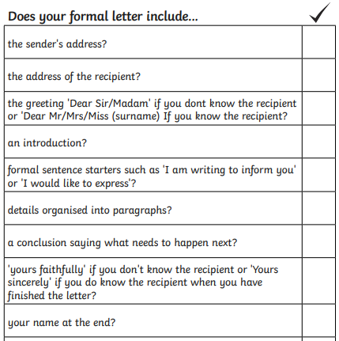 | Newspaper report  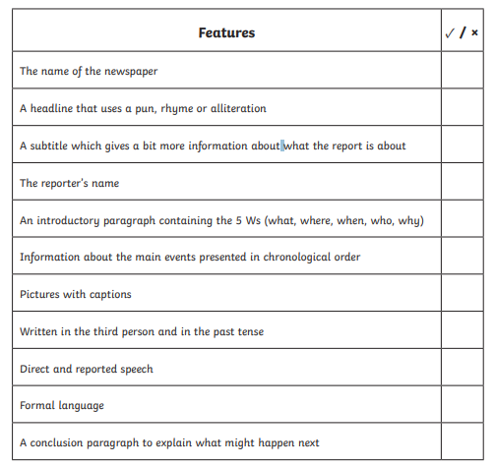

Letter of complaint example 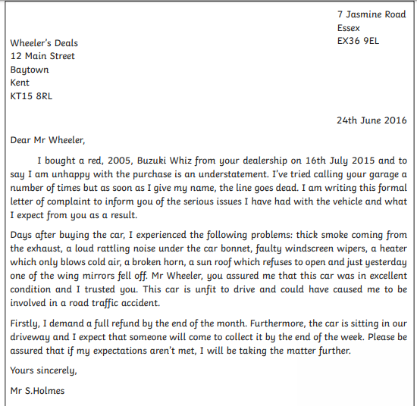

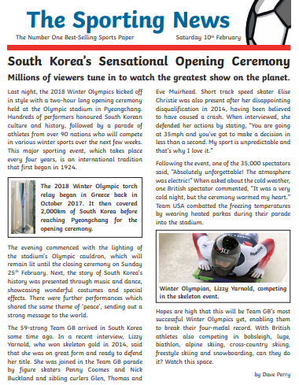
Newspaper report example

