Monday

- 49, 678 + 14,567 =
- 693,657 + 472,483 =
- 96,485 – 12,847 =
- 873,248 – 64,482 =
- 64 x 85 =
- 345 x 34 =
- 384 ÷ 6 =
- 336 ÷ 7 =
- 364 = 3.64 x _______
- 9.73 = _____ ÷ 10
Tuesday
- Round 53,729
- To the nearest 10 =
- To the nearest 100 =
- To the nearest 1000 =
- To the nearest 10,000 =
- What is the value of the underlined digits?
- 9, 263,918
- 3,493,416
- 8,903,401
- 2,522,903

- Write this number in words: 25,309,086

- Write this number using numerals: Eight million, four hundred and twenty thousand, two hundred and forty-six

- Six million, two hundred and sixty thousand, three hundred and fourteen is written as
6,206,314. True or False? Prove it!

Wednesday

- Find 10% of 450

- Find 20% of 450

- Find 50% of 450

- Find 25% of 450

- Find 1% of 450

- 96.2 + 35.7 =

- 354.8 + 56.9 =

- 257.8 – 64.2 =

- 703.9 – 37.05 =

- 503.6 x 10 =

Thursday

- 1 hour = ________ minutes
- 1 minute = _________ seconds
- 1 day = ________ hours
- 365 days = _________ year
- _______ months = 1 year
- _______ weeks = 1 year
- 48 hours = ________ days
- 90 minutes = _________ hours
- 180 seconds = _________ minutes
- 5 hours = _________ minutes

Friday

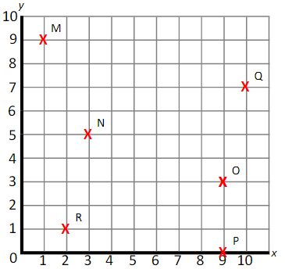
- What are the coordinates of the crosses?

- Plot the following points:
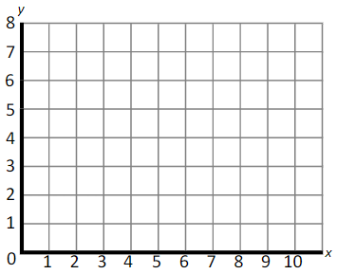

A (6,2)
B (9,0)
C (4,8)
D (0,4)

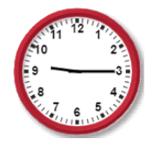
- If this clock represents the time at night, how is this time written on a 24-hour digital clock?

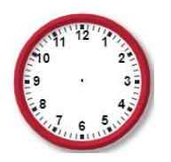
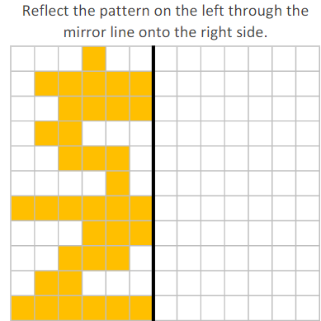
- Draw the hands on the clock to represent 4:10.

5)

