Monday

- 49, 678 + 14,567 = 64,245
- 693,657 + 472,483 = 1,166,140
- 96,485 – 12,847 = 83,638
- 873,248 – 64,482 = 808,766
- 64 x 85 = 5,440
- 345 x 34 = 11,730
- 384 ÷ 6 = 64
- 336 ÷ 7 = 48
- 364 = 3.64 x 100
- 9.73 = 97.3 ÷ 10

Tuesday

- Round 53,729
- To the nearest 10 = 53,730
- To the nearest 100 = 53,700
- To the nearest 1000 = 54,000
- To the nearest 10,000 = 50,000
- What is the value of the underlined digits?
- 9, 263,918 = 9 million or 9,000,000
- 3,493,416 = 90 thousand or 90,000
- 8,903,401 = 900 thousand or 900,000
- 2,522,903 = 9 hundred or 900
- Write this number in words: 25,309,086
Twenty-five million, three hundred and nine thousand, and eighty-six
- Write this number using numerals: Eight million, four hundred and twenty thousand, two hundred and forty-six 8,420,246

- Six million, two hundred and sixty thousand, three hundred and fourteen is written as
6,206,314. True or False? Prove it! False, it should be 6,260,314
Wednesday

- Find 10% of 450 = 45

- Find 20% of 450 = 90

- Find 50% of 450 = 225

- Find 25% of 450 = 112.5

- Find 1% of 450 = 4.5

- 96.2 + 35.7 = 131.9

- 354.8 + 56.9 = 411.7

- 257.8 – 64.2 = 193.6

- 703.9 – 37.05 = 666.85

- 503.6 x 10 = 5036

Thursday

- 1 hour = 60 minutes
- 1 minute = 60seconds
- 1 day = 24 hours
- 365 days = 1 year
- 12 months = 1 year
- 52 weeks = 1 year
- 48 hours = 2 days
- 90 minutes = 1 and a half hours
- 180 seconds = 3 minutes
- 5 hours = 300 minutes

Friday

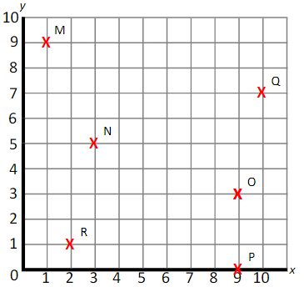
- What are the coordinates of the crosses?
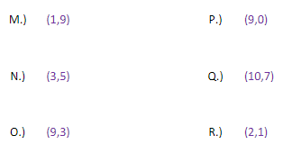

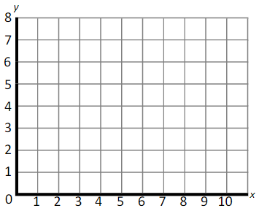

- Plot the following points:
A (6,2)
B (9,0)
C (4,8)
D (0,4)

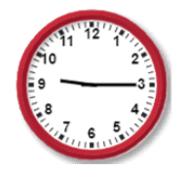

- If this clock represents the time at night, how is this time written on a 24-hour digital clock?
21:15

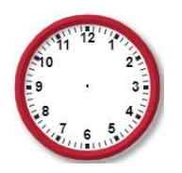

4) Draw the hands on the clock to represent 4:10

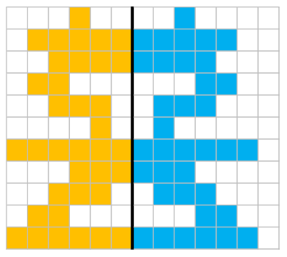

5)

