Monday

- 749, 678 + 84,567 = 834,245
- 2,693,997 + 978,483 = 3,672,480
- 96,005 – 12,847 = 83,158
- 803,248 – 64,489 = 738,759
- 564 x 87 = 49,068
- 867 x 69 = 59,823
- 512 ÷ 16 = 32
- 3776 ÷ 8 = 472
- 3684 = 3.684 x 1000
- 9.73 = 973 ÷ 100
Tuesday
- Round 453,991
- To the nearest 10 = 453,990
- To the nearest 100 = 454,000
- To the nearest 1000 = 454,000
- To the nearest 10,000 = 450,000
- What is the value of the underlined digits?
- 96, 263,918 = 90 million or 90,000,000
- 3,493,416 = 90 thousand or 90,000
- 8,03,401.09 = 9 hundredths
- 2,522,903 = 9 hundred or 900
- Write this number in words: 305,309,086
Three-hundred and five million, three-hundred and nine thousand, and eighty-six
- Write this number using numerals: Eighty-three million, four hundred and twenty thousand, two hundred and six 83,420,206
- Six million, two hundred and sixty thousand, three hundred and fourteen is written as
6,206,314. True or False? Prove it! False, it should be 6,260,314

Wednesday

- Find 18% of 450 = 81

- Find 23% of 450 = 103.5

- Find 60% of 450 = 270

- Find 87% of 450 = 391.5

- Find 99% of 450 = 445.5

- 96.92 + 35.78 = 132.7

- 354.78 + 256.9 = 611.68

- 257.08 – 64.2 = 192.88

- 703.01 – 37.25 = 665.76

- 503.06 x 1000 = 503060
Thursday

- 365 days = 1 year
- 52 weeks = 1 year
- 72 hours = 3 days
- 270 minutes = 4 hours and 30 minutes
- 780 seconds = 13 minutes
- 5 hours and 12 minutes = 312 minutes
- 8.32 kg = 8320 g
- 5025ml = 5.025 litres
- 14.75 km = 14750 m
- 3250 mm = 325 cm

Friday

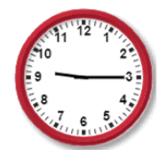

- If this clock represents the time in the morning, what would a digital representation say 15and a half hours later?
00:45

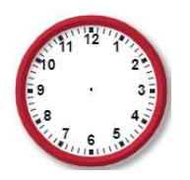

- Draw the hands on the clock to represent 21:53

3)
a) Jim started the race at 09:30. He completed it at 11:28. How long did it take him?
1hour and 58 minutes

b) Frank did the same race as Jim but completed it in a time of 2 hours and 36 minutes. What time did Frank finish? 12:06 or Six minutes past 12

c) Who was fastest and by how much? Jim was 38 minutes faster that Frank.

4) Write today’s date in Roman Numerals. V.VI.MMXX (5.6.2020)

- What number is represented? MMCCCLXIV 2369

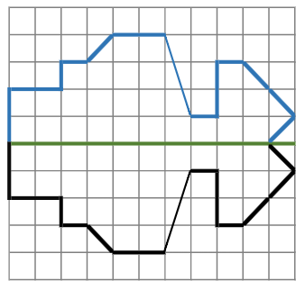
- Reflect the image

- Find the missing angles:

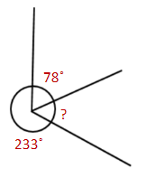

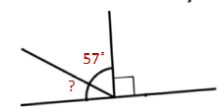

33° 49°

