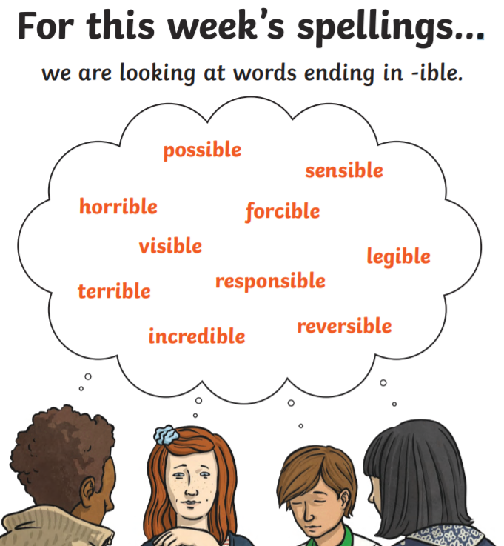

Friday 5th June
How many spelling words can you use in a single paragraph story? Be creative!

