
SLS Parent Newsletter
Autumn 2 2022

Here are some of the exciting local reading events for children and young people coming up during December.

Kids activities in Portsmouth Public Libraries



All of the library activities are free of charge unless stated otherwise.

Christmas Rhyme time with visit from Santa


Come to meet Santa! Free and drop-in unless specified.
Alderman Lacey Library: Friday 23 December, 10am
Carnegie Library: Wednesday 21 December, 10am
Central Library: Wednesday 14 December, 10am
Cosham Library: Friday 16 December, 11am
North End Library: Monday 12 December, 11am
Paulsgrove Library: Wednesday 14 December, 2pm
Portsea Library: Thursday 15 December, 11am
Santas Grotto
Southsea Library
Friday 16 and Saturday 17 December. Santa will be in his grotto from 10am to 12pm. Every child gets a present. Tickets £1 bookable in advance. Please book by popping into Southsea Library.
Beddow Library
Friday 23 December: Santa will be in his grotto from 2.30pm to 4.30pm. Every child gets a present. Tickets £1 bookable in advance. Please book by popping into Beddow Library.
Christmas Crafts

Alderman Lacey Library
Tuesday 20 December, 11am: Make your own Christmas decorations.
Also, throughout the Christmas holidays there will be a Christmas tree hunt. If you find the trees hidden in the library, you get a sweet!
Beddow Library
Tuesday 13 December, 10am: Bitesize Christmas Story time for babies.
Friday 16 and 23 December, 10am: Christmas story time.
Thursday 22 December, 3.30pm: Make a stained-glass angel.
Christmas tree decoration competition: open to adults and children. Design and make your own tree decoration and bring to Beddow Library. Judging will commence on 18 December and there will be a prize for the best adult and child entries.
Also, there will be ongoing bauble hunt (to win a sweet) and a post box for letters to Santa – the Beddow Library Elves will reply to all letters.
Carnegie Library
Tuesday 20 December, 11am: Listen to the Snowman story and make a Christmas decoration.
Friday 30 December, 11am: Winter story and craft 11am.
Central Library
Wednesday 21 December, 10am: Christmas Elf singalong and make a Christmas decoration.
Friday 23 December, 11am: Listen to the Nutcracker musical story and make a Christmas decoration.
Wednesday 28 December 10am: Winter story and craft 10am.
Friday 30 December, 11am: Harry and the Snow King story and craft
Cosham Library, North End Library, Paulsgrove Library
There will be crafts to take away or do in these libraries throughout festive period.
Portsea Library
Thursday 22 December, 11am: Christmas Elf singalong and make a Christmas decoration.
Thursday 29 December, 11am: Snowball story and craft 11am.

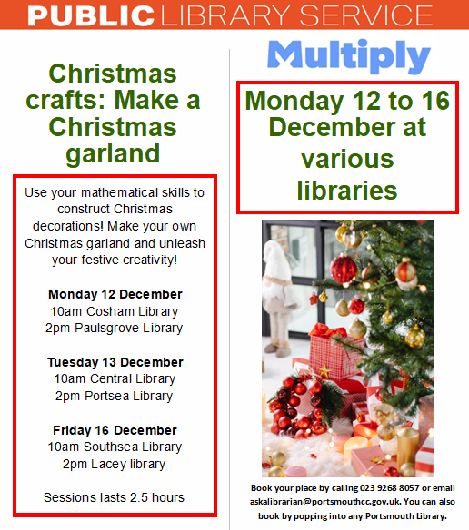

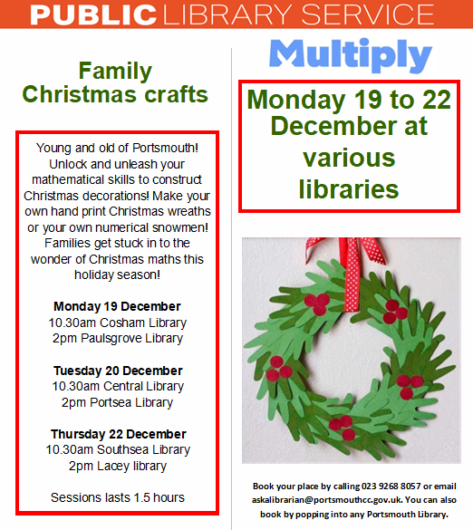

Code Club at Southsea Library and Cosham Library


Every Saturday at Southsea Library.
Beginner’s group: 3pm to 4pm
Advanced group: 4.15pm to 5.15pmIf more information on joining these clubs call Southsea Library on 023 9268 8999 or email southsea.library@portsmouthcc.gov.uk.
Every Thursday at Cosham Library 4.00-5.00pm.
If more information on joining these clubs call Southsea Library on 02392 834210 or email cosham.library@portsmouthcc.gov.uk.
Children’s drawing workshop at Southsea Library
The drawing workshop is running on 17th December, 2.30 to 4.30pm.

Fort Nelson



A Victorian Christmas
Festive tales from the garrison

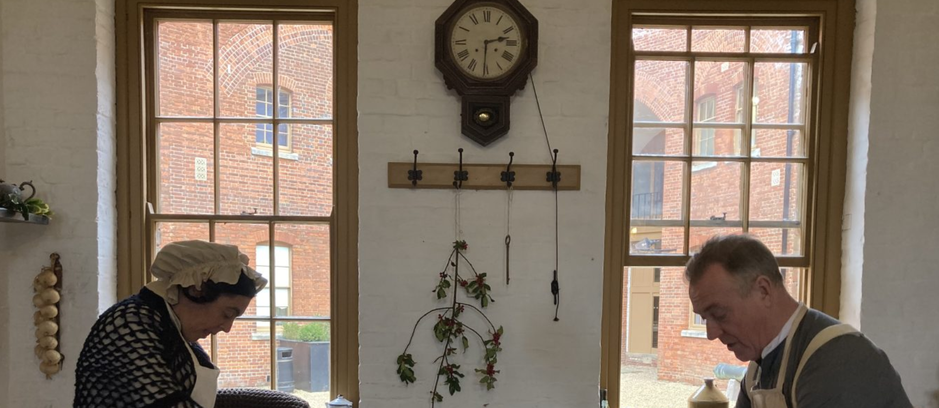

17th December, 10:00 am to 18th December, 4:00 pm
Christmas in a military establishment is a time for good food, good comrades and, most importantly, good entertainment! Join the men of the garrison and their wives as they plan how they will celebrate – it’s like a military operation, so anything that could go wrong just might! Step back in time and meet a cast of characters who will bring to life what Christmas would have been like in a Victorian garrison, plus there’ll be festive activities for our younger visitors.
There’ll also be traditional make-and-take craft activities, including Christmas cards, paperchains and decorations, plus a reindeer trail.
Admission to the Fort is free but please pre-book your visit online to guarantee your visit.

Aspex Gallery


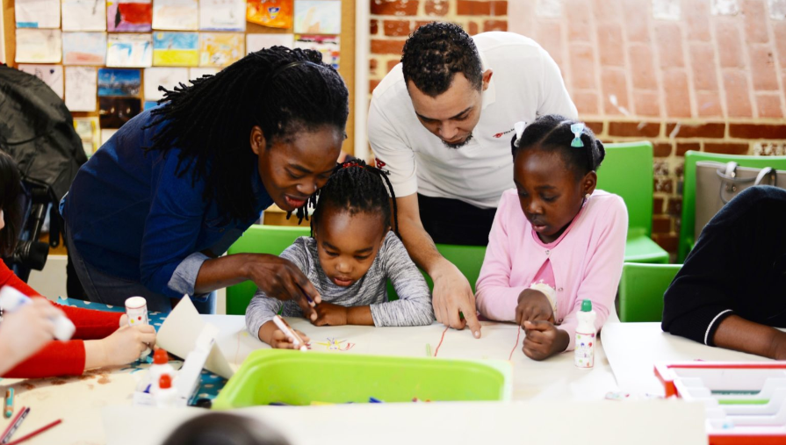

Every Saturday, 11am–1pm
Welcome to Family Saturdays! Join us for free creative workshops suitable for the whole family.
Explore a different creative activity each week, such as painting, model making, print making, and inventing in these relaxed sessions suitable for all ages, interests and abilities.
Please note that we will be admitting a maximum of 30 people into our Learning Space at any one time. All are welcome to wait in our cafe or explore our exhibitions if a queue develops.
Please help us continue to offer free and affordable family activities by making a suggested donation of £1 per person. You can do this on the day by popping a coin in our donation box. Thank you!



