Court Lane Junior School Planning Proforma - Science
Year: 3  Class:  Kinney  Walliams  Dahl  Donaldson | Subject: Science  Unit: Plants  Term: Spring 2  BIG IDEA: Plants use some of their parts to grow and some parts to make more plants similar to themselves.  Learning Journey: (KPIs in order of journey)  - To understand the different parts of a flowering plant and their functions.  - To understand how different conditions can have an effect on plant growth.  - To understand how water is transported through plants.  - To understand the life cycle of a plant.  KEY VOCABULARY:  air, light, water, nutrients, soil, reproduction, transportation, dispersal, pollination, flower, phloem, xylem, stem, petal, root, leaf, photosynthesis | 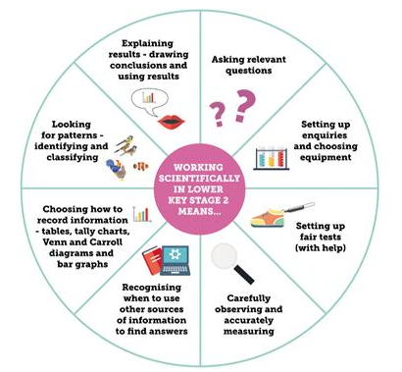  Working Scientifically (LKS2)  8  7  6  5  4  3  2  1 |   Enquiry Process:            

Pre Asses | KEY VOCABULARY ASSESSMENT SHEET – remember you can draw a diagram with labels, write an example or both to show your understanding of each word.  PLANTS UNIT PRE ASSESSMENT TEST - the question can be read to you but you have to answer independently.
2 | LO:  To understand the different parts of a flowering plant and their functions | Practical Based Learning:  Find a healthy living plant that you could use to dissect and label. Dissect each part of the plant to show that you have understood what a petal, leaf, stem, root and a flower is.  Once completed, begin investigating how many of the same plant parts you can find on different species. Create a way of presenting this data and see what there is most of in your garden e.g. there are more different species of leaf than there are flower. This could be completed in the form of a pictogram. Remember to take a picture of it and write notes around it to tell us what you have found out. | Knowledge Based Learning:  Explain what a root is and does.  Explain what a leaf is and does.  Explain what a flower is and does.  Explain what a stem is and does.  Explain what a petal is and does.  Link these to your dissected parts if you can.
3 | LO:  To understand how different conditions can have an effect on plant growth. | Practical Based Learning:  Set up an investigation in your house and garden. Plant some seeds in different growing conditions ( without water, without light, without soil etc) and monitor its progress over the course of two weeks. Think about the constants (things that should stay the same) and variables (things that can be changed). Predict which condition you think the seeds will grow best in. (CRESS IS A VERY GOOD SEED TO USE FOR THIS INVESTIGATION AS IT CAN GROW QUITE QUICKLY).  Remember to observe your seedlings daily and water when necessary. When you begin to notice changes and/ or growth, note it down in the form of a description, labelled diagram or both. This will be your evidence.  After a couple of weeks, have a look to see which seedlings grew the best. What conditions were these in? Was your prediction correct? Explain why you think this was.  You can design your own way of planning and presenting this information. | Knowledge Based Learning:  Explain what a plant needs to survive.  Predict what might happen if one or more of these elements are taken away.  Explain why certain growing conditions affect the plants in different ways.  Research the term ‘photosynthesis’. Draw a diagram that shows your understanding of this. The way you draw it should help with your understanding of what is happening to plants.
4 | LO:  To understand how water is transported through plants. | Practical Based Learning:  Choose a tree and attach a clear and empty plastic bag to a branch by enclosing the leaves and sealing the bag (or tying the handles in a knot) to keep it in place. After a week, observe what happens to the bag. It should go misty as it now contains water. Where has this come from and why has is appeared?  How can you turn a white flower, a different colour? Investigate through questioning, creating an investigation and exploring what works and what doesn’t. Record what you find out. | Knowledge Based Learning:  Explain how water is transported up the plant. Where does it come from? What is it used for? Use diagrams to help with your explanations.  Recap that plants, including trees, absorb nutrients and water from the soil through their roots. The water flows through the trunk(stem) of the tree, along the branches and to every leaf. The leaves use the water, with other things like sunlight and carbon dioxide, to make their food and stay healthy. Some of this water is returned to the air and this is what has been captured in the bag.
5 | LO:  To understand the life cycle of a plant. | Practical Based Learning:  In your garden or an outside space, create ways that could encourage insects and wildlife to visit. These creatures will help with pollination as well as the ourselves and the wind. All creative designs that have been put into action will be awarded housepoints and a special certificate. | Knowledge Based Learning:  How are seeds dispersed (spread)?  Why are seeds dispersed?  Explain (in some way) what pollination is.  How could we help in this process?  Do all seeds disperse in the same way? Why? Why not?
Post Assess | KEY VOCABULARY ASSESSMENT SHEET - remember you can draw a diagram with labels, write an example or both to show your understanding of each word.  PLANTS POST UNIT ASSESSMENT TEST – the question can be read to you but you have to answer independently.

