
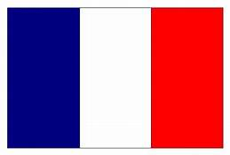

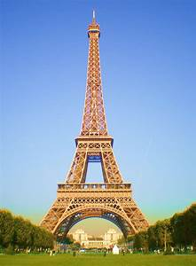
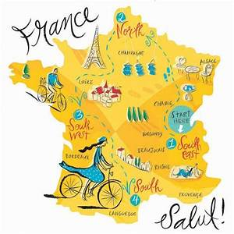
Can you paint/sketch a picture of the Eiffel Tower?
Did you know that France isn’t the only place where French is spoken?
Can you find out about another country where France is spoken?
Some countries you could investigate are – Canada, Luxembourg or Morocco.
What is it like there?
Last term we looked at Europe and the Mediterranean area.
The weather has been brilliant here for the last few weeks – but has it been the same in France?
Can you write a weather report for Paris, Marseille or Nice?
Try and make it interesting – how hot? Would you need a sun hat? Sunglasses or would you need a coat and umberella?

Read through the powerpoints – can you create
either
- A fact file or information poster about France
- Can you compare France and the UK?
That you ended up in France.
How would you say hello?
Try having a first conversation in French with someone at home.
Watch some clips about French places and culture on the BBC Bitesize webpage
https://www.bbc.co.uk/bitesize/topics/zsbjmp3/resources/1

Learning theme:

France

What is it like to live there?

Imagine …

