SCIENCE : WEEK BEGINNING Monday 18th May 2020

Monday Activity:  Natural and Artificial Light  - Sort each picture at the bottom of the page. Is it artificial (man-made) light or natural light?  - Draw a picture of natural light and then a picture of artificial light. Use detail and be creative!  LIGHT READING  - Read the information about light and highlight anything you might think is useful to remember for this week. | 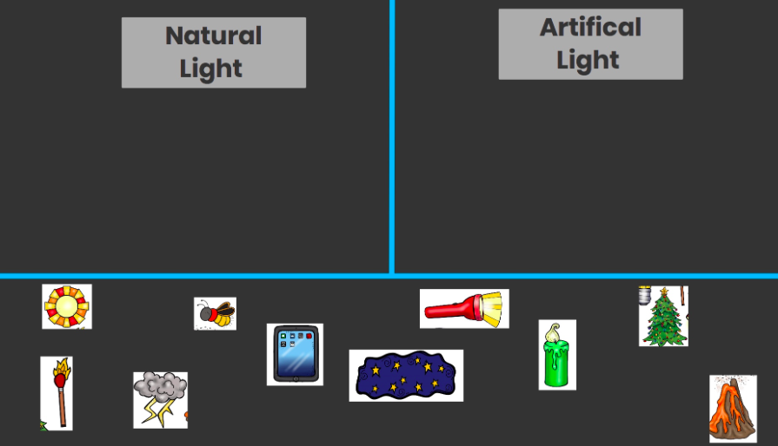  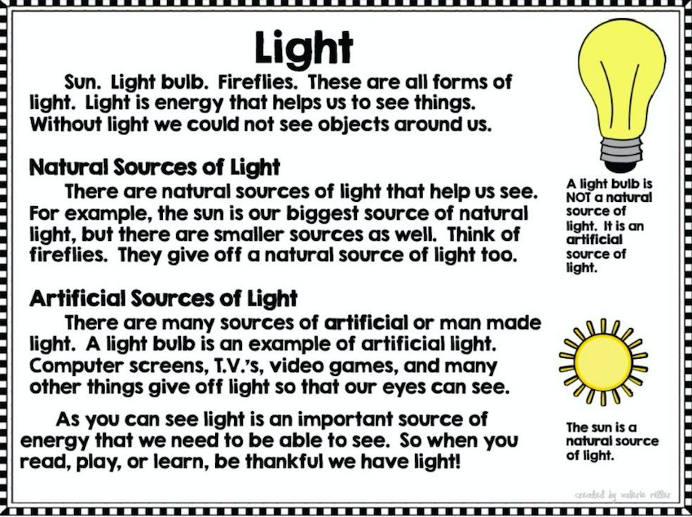
Tuesday Activity:  SOURCES OF LIGHT  - Tick which objects that you think are light sources (where light is created). Take 1 minute to discuss any you are not sure of. Good luck!  LIGHT ENERGY: HOW DO WE USE IT?  - Using pictures, add objects we use because of the invention of the lightbulb.  - Put a new invention into each new box. | 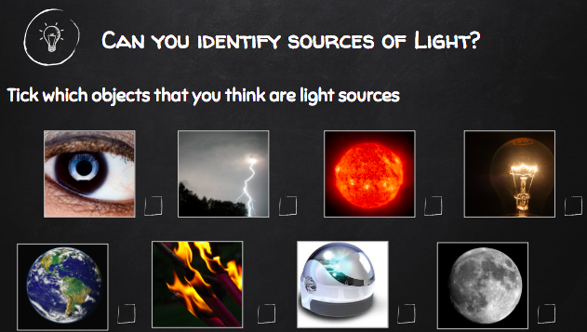  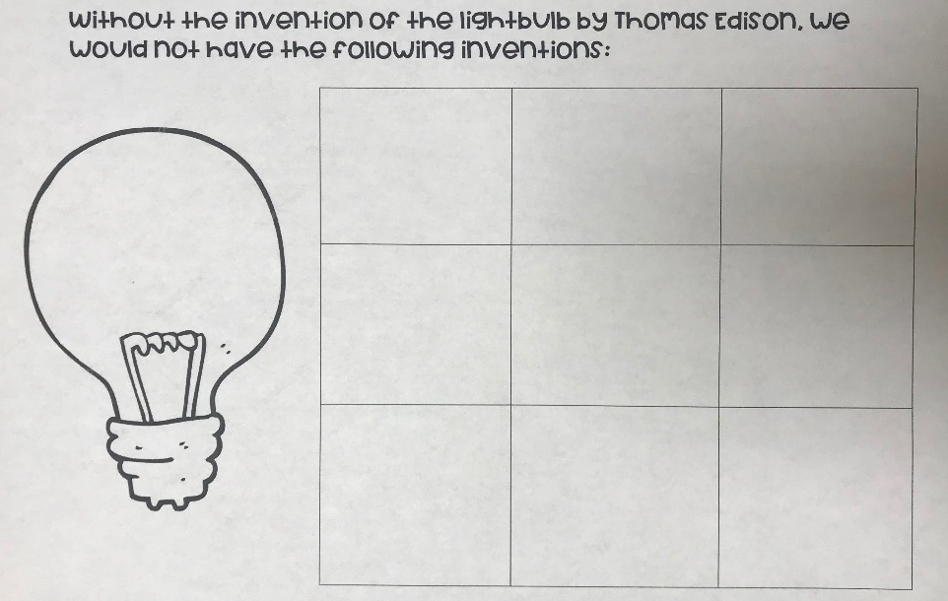
Wednesday Activity:
LIGHT ENERGY
- Draw a picture of 3 examples of light energy. Write the name of the light energy under the picture.
Thursday Activity:  LIGHT EXPERIMENT  - Pick an object from around the house.  - Predict if it will be transparent, translucent, or opaque. Tick 1 box.  - Shine the light on the object. What do you observe? Draw a picture to match, and check off your final answer.  - BONUS: Discuss your observations. | 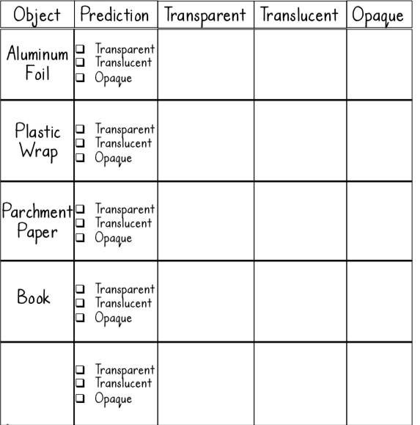
Friday Activity:  SHADOW PUPPETS  - Cut out a shape or animal out of black construction paper  - Using a torch, explore how your shape or animal reacts to the torch by using it as a shadow puppet. What happens to your shape when the torch is close to your shadow puppet? What happens to your shape when your torch is far away from your shadow puppet?  - After exploring, draw your responses and on paper think about these questions:  - "Using a torch, if you had the classroom lights on would you be able to see your shadow puppet better or worse than if the classroom lights were off? Why?" | 

