Court Lane Junior School Planning Proforma - Science
Year: 3  Class:  Kinney  Walliams  Dahl  Donaldson | Subject: Science  Unit: Light and Dark  Term: Summer 2.  BIG IDEA: There is darkness without light. Light reflects of different surfaces.  Learning Journey: (KPIs in order of journey)  - I know that light is needed in order to see things and darkness is the absence of light.  - I notice that light is reflected from surfaces.  - I know that light from the sun can be dangerous and that there are ways to protect our eyes.  - I know that shadows are formed when the light from a light source is blocked by a solid object.  - I can find patterns in the way that the size of shadows change.  KEY VOCABULARY:  light, shadow, dark, mirror, reflect, reflective, reflection, opaque | 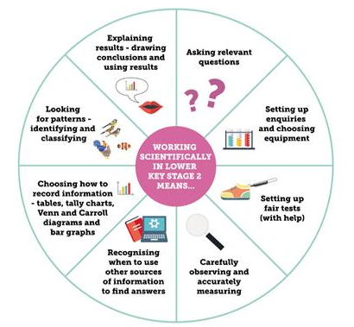  Working Scientifically (LKS2)  8  7  6  5  4  3  2  1 |   Enquiry Process:            

Pre Asses | KEY VOCABULARY ASSESSMENT SHEET – remember you can draw a diagram with labels, write an example or both to show your understanding of each word.  Light and Dark UNIT PRE ASSESSMENT TEST - the question can be read to you but you have to answer independently.
2 | LO: I know that light is needed in order to see things and darkness is the absence of light.  Working Scientifically:  1, 5, 8  Enquiry Process: | Practical Based Learning:  Children to explore darkness. Using black sacks and other dark materials, enable children to create blackout dens under their tables. These must be dens which block out complete light as best as they can. Children are then to explore what they can see.  After grasping concept, children are to discuss what a light source is and what is not through identifying and classifying. | Knowledge Based Learning:  Children to understand the concept that we need light to see.  Children to understand: What they can see? Why they think this is? What will help them to see?  If children can see anything inside their cave, their investigations will be null and void. The idea is to create complete darkness and understand that light is needed in order to see.  Children to understand that light sources are sources of light and not objects that are reflecting light.
3 | LO: I notice that light is reflected off surfaces.  Working Scientifically:  2, 4, 5, 1  Enquiry Process: | Practical Based Learning:  Create the perfect shield for Perseus to protect him when battling the gorgon, Medusa. This shield needs to have the most reflective material. When you have found the perfect material, attach it to a cardboard shield template before putting it into action.  Teacher to test each shield by shining two torchlights at the shield (representing the eyes of Medusa). The other children can then give the material a score out of 5 in relation to which they think is the most reflective material. (1 being poor and 5 being perfect). | Knowledge Based Learning:  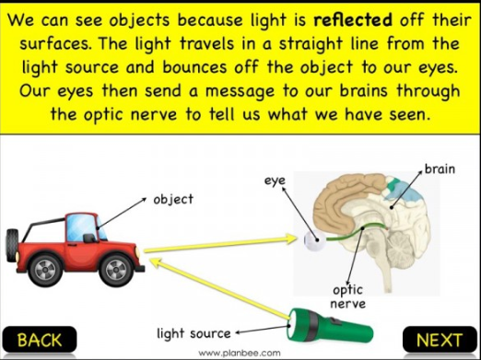  Explain how we can see objects in your own words. What would be the best key vocabulary to use?
4 | LO: I know that light from the sun can be dangerous and that there are ways to protect our eyes.  Working Scientifically:  2, 4, 5, 8, 1  Enquiry Process: | Practical Based Learning:  Using UV beads, children to set up an investigation to see the effect that direct sunlight has on the skin. UV beads are a replacement for skin in order to see the effects of sunlight. These change colours when exposed.  The investigation can also be used to test the tints in sunglasses that protect our eyes from UV light.  Children to place an agreed number of beads into a clear, sealable bag and then apply a different strength sunscreen or material to the outside of the bag, covering the beads, before leaving them in direct sunlight for around 10 minutes. There should be one control bag that is not covered to see the comparison. | Knowledge Based Learning:  If the beads do not change colour, this means that they have been protected the most form harmful UV light.  It is not good practice to look directly at the sun. If you do, this can lead to your vision being damaged. If we catch sight of the sun, it is instinctive to turn away and close our eyes but if we stare at it for more than a few seconds, it can damage our retina and cause temporary blindness and blurriness. This can sometimes also cause total blindness. Protecting our eyes prevents this, especially in sunny environments. Often, people who are regularly in these conditions develop eye problems over time.
5 | LO: I know that shadows are formed when the light from a light source is blocked by an object.  Working Scientifically:  2,8,6  Enquiry Process: | Practical Based Learning:  Using a clear Greek myth (e.g. Perseus and Medusa), children to create templates of the characters using cardboard. These are then to be attached to longer rods (similar to a flag). Using these, once completed, children are to set up a white material screen with a light shining on to it (lamps would be useful for this, instead of torches). From here, children are to investigate how to make their shadows larger and smaller.  Children to use secondary resources (books) to help with their understanding of shadows. | Knowledge Based Learning:  Children to understand that shadows are formed when direct light from a source is blocked by an opaque or translucent object. These shadows can reduce and enlarge in size depending on where the light source is placed and also where the object is placed – in this case the puppet they have made.  Children can also investigate this outside using themselves in direct sunlight and seeing if their own shadows change size and shape.  Shadows are the areas where light reaching that particular area is less intense. They also require a light source in order to be formed.
6 | LO: I can find patterns in the way that the size of shadows change.  Working Scientifically:  2, 8, 6  Enquiry Process: | Practical Based Learning:  Following on from last lesson, children to retell their Greek myth using shadow puppetry and perform to the rest of the class, showing what they have learned in terms of shadow formation and size that link to different parts of the story.
Post Assess | KEY VOCABULARY ASSESSMENT SHEET - remember you can draw a diagram with labels, write an example or both to show your understanding of each word.  Light and Dark POST UNIT ASSESSMENT TEST – the question can be read to you but you have to answer independently.

