Wider Curriculum Home Learning – Healthy living
From the emails, photos and conversations over the phone – many of you are saying how you are enjoying helping your parents to cook. Whether it is your evening meal or some delicious treats. This week we would like you to explore ‘healthy eating and living’.
Choose an activity from below to show your understanding of keeping healthy and making healthy living choices.
Funky fruit and vegetable art  Fruit and veg are a delicious, healthy snack.  To make eating fruit and vegetables even more fun, try making a funky picture with it!        You could even take a picture of your favourite fruit and add on hair, eyes and other features on it on using SeeSaw!  Use Mr Potato Head from Toy Story as an example | Healthy meal plan  https://www.nhs.uk/live-well/eat-well/the-eatwell-guide/  Using the Eatwell guide, have a go at creating a healthy meal plan.  What will you eat for breakfast, lunch and dinner?  Can you present your knowledge of the Eatwell plate?  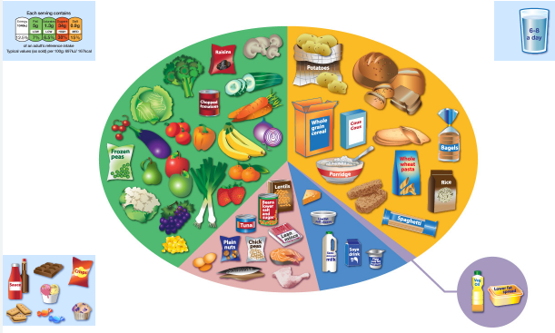 | Yoga  Yoga can enhance your strength, co-ordination and flexibility, while encouraging body awareness and self-esteem.  It can reduce your worries and promote a sense of calmness.  Have a go at some of the poses on the PowerPoint.  Take a picture and share with your teacher on SeeSaw.  
Cook a meal for your family  Can you help cook or prepare a meal for your family? Maybe have a “Come Dine With Me” evening or evening where you each prepare or help prepare and evening with some games and entertainment.  Take a picture or video and share it with you teacher on SeeSaw.   | School Games Mark June  Complete this week’s challenge (or if they are still active try some of the others) – remember the more children take part the more points we get towards our school total and the competition!   | I pledge…  We would like you to think about something you would like to do or achieve in order to become live a healthier lifestyle – especially since some of us have had our outdoor time restricted.  For example...  - I pledge to eat 5 fruits or vegetables a day  Or  - I pledge to walk 10,000 steps a day  Once you have thought about your pledge, complete the pledge template.  
Remember to share your work with your teacher using seesaw or the class email address

